**The Coding Manual**

# 1 Coding Manual Instruction

The primary aim of this coding manual was to standardize the coding procedure and eliminate inconsistencies across coders.

# 2 Coding Procedure

The whole process of coding is divided into two stages: coding and proofreading stages.

2.1 Coding Stage

Reading the method section

For studies used secondary data, data from web or app scraping, large-scale databases or using animals, or case studies will be excluded, only extracting its brief information

1000 empirical articles

Extracting the target articles’ complete information

Figure 1. The procedure of the coding stage

2.1.1 Method section[1]

First, we will read the methods part to check whether the data for the study came from a large dataset or secondary data[2], or whether it was an animal study, a case study, or data from web or app scraping. If yes, we will only record the brief information of the articles[3]. If not, we will extract the complete information from the articles according to the third part of this manual.

Repeat the above steps until all the literature has been coded.

2.2 Proofreading stage

(1) To further increase the reliability and objectivity of the coding content, after the coding stage, we re-discussed and developed the criteria that had big differences from the previous coding process.

(2) During both the coding and proofreading stages, coders are divided into groups, with each group having two coders coding the same document. If discrepancies arise, they refer back to the original document and agree on a result. If consensus cannot be reached, the project leader makes the final decision.

# 3 The Detailed Information of Code Dimensions

* **Article IDs**

Each article has a unique ID (8 digits)

* **Article title**

Please use Chinese when extracting information.

* **First author**

Please use Chinese when extracting information.

* **Journal**

Please use Chinese when extracting information.

* **Abstract**

Whether to report subject information: 0. Unreported; 1. Reported.

If the subjects include college students, is it mentioned in the abstract? 0. Not mention; 1. Mention.

*Note: Subject information includes: 1. Sample type; 2. Educational attainments; 3. Occupation; 4. Sample size; 5. Gender; 6. Age; 7. Socioeconomic status; 8. Ethnicity; 9. Religious; a. Hukou; Ancestral home/origin; Permanent residence; Place of origin for students; b. Subject recruitment area.*

* **Target population**

Target population: 1. Stated specific population; 2. Stated general population; 3. inferred general population.

Coding basis: exacting sentences/words excerpted from the full text of the paper that are associated with the statement about the target population.

*Note: The coding of the target population mainly reads the discussion part of the article, especially the conclusion, limitations, and other parts. If no such information was found, coders could read the conclusion in the abstract or elsewhere in the article. The following provides a decision tree for understanding the coding of the target population:*

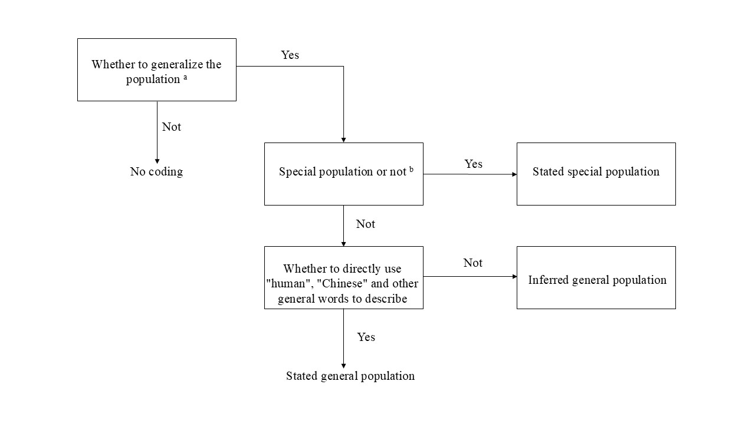

Figure 2 The decision tree of the target population coding

*a. Here are two refined examples to elucidate the distinction between generalizing and not generalizing a conclusion:*

*example 1: Two research teams investigate the loneliness experienced by Chinese teenagers, specifically targeting teenagers in Shanghai as their sample. Both teams uncover high levels of loneliness among the Shanghai teenagers. Team 1 hastily generalizes, concluding that the study reveals that Chinese adolescents generally feel more lonely. Conversely, Team 2 acknowledges the specific nature of their sample, stating that the study found adolescents in Shanghai to be more lonely while suggesting further research is needed to ascertain whether teenagers in other regions share the same psychological state. In this instance, Team 1 makes an expansive generalization, extending their findings from Shanghai teenagers to all Chinese teenagers; Team 2 refrains from such generalization.*

*example 2: Consider two teams examining the cognitive processing of attention. Team 1 reaches a conclusion, implicitly generalizing that the study has uncovered the mechanism of attention cognitive processing to be xxx for all humans. Team 2, however, restricts their conclusion to the study's specific findings, stating that the cognitive processing mechanism of attention is xxx in the context of their research. Team 2 also acknowledges that future exploration is necessary to determine whether the subjects studied can be generalized to a broader population. In this scenario, Team 1 implicitly generalizes their findings to all humans, whereas Team 2 refrains from direct generalization.*

*b. Special population: This category encompasses, but is not limited to, infants, adolescents, the elderly, individuals with mental illnesses, prisoners, and other such demographics.*

* **Study number[4]**

*Note: 1. Study number refers to the number of studies in the article from which the encoded information is extracted; 2. If there is pre-research in the article, it is necessary to decide whether to code it after discussion according to the actual situation. If coded, the pre-study code is 0, and the study number of other formal studies is unchanged. If there are multiple pre-studies, then the first pre-study is 0, the second 0.1, the third 0.2, and so on. 3. If several small studies appear in a large study, such as study 2a and study 2b, the study numbers are recorded as 2a and 2b, and separate rows are used to record the information. 4. If the same batch of subjects is used in different studies in an article, only the data of the first study using the same batch of subjects need to be recorded, Other studies only need to record “Study number”, and the “Remark 2” is coded: Subject repeated use.*

* **Remark 1**

*Note: Secondary data research, qualitative research, animal research, data mining research, and other literature are not applicable to the purpose of this study. Please note the first four cases as: secondary, qualitative, animal, and mining respectively. For other documents that are not applicable to our study, please write your reasons.*

* **Study Type**
  + - 1. Experimental/quasi-experimental; 2. Questionnaire; 3. Others (fill in the text)

*Note: Conceptually, experimental research utilizes the experimental method, which involves observing psychological phenomena under controlled conditions. Questionnaire research, in contrast, employs the questionnaire method, a research technique that collects data on psychological variables through structured written surveys.*

*If coders are unable to determine which method was used, they can review the methodology, abstract, or other sections of the paper to ascertain the author's description.*

* **Subjects groups**

*Note: If the demographic information of participants in the same study is reported by different groups (e.g., young adults vs. older adults), please record the participants' information on separate rows. In cases of multi-level grouping, please record according to the actual situation in the article to ensure the most complete recording of participant information, the simplest grouping form, and independence between groups.*

* **Sample type**
  + - 1. University students (including graduate students); 2. Students but not university students; 3. Infants, toddlers, preschool children; 4. Adults who are not students; 5. Others
    - Extract sentences or words of papers that associated with sample type.

*Note: 1. Infants are aged 0-1, toddlers are aged 1-3, and preschoolers are aged 3-6. 2. Studies covering multiple sample type or unspecified groups should be recorded as "Other". 3. For longitudinal studies where participants' statuses change over time, the sample type should be based on the study's main focus population. 4. On-the-job graduates should be coded as "4. Non-student adults". 5. When extracting information from the original text, ensure it forms a complete sentence indicating the sample type.*

* **Educational attainment**
  + - 0. Unreported; 1. Reported
    - Educational attainment information: The coders extract the original descriptions of the subject's educational level

*Note: Enter this code only when the Sample type is 4 or 5.*

* **Occupation**
  + - 0. Unreported; 2. Reported

*Note: Enter this code only when the Sample type is 4 or 5.*

* **Sample size**

*Note: 1. The Sample size should primarily reflect the number of valid participants in the study. If the paper does not provide the number of valid participants, please record the sample size before excluding invalid participants. 2. If an article contains both tables and textual descriptions, the textual descriptions should take precedence.*

* **Gender**
  + - 0. Unreported; 1. Reported
    - Number of men (%) / Number of women (%)

*Note: 1. If the article provides both the number of males and females as well as their respective percentages, please prioritize recording the numbers.2. If the article only provides the number or percentage of one gender, please calculate and fill in the number or percentage of the other gender that is not reported.*

* **Age**
  + - 0. Unreported; 1. Reported
    - If reporting, please extract details of age.

*Note: 1. If the article reports multiple indicators of age, please record them all whenever possible. 2. If the age information in the article is given in months or days, please convert it to years and fill in the result, retaining two decimal places after conversion.*

* **Socioeconomic status**
  + - 0. Unreported; 1. Occupation; 2. Educational attainment; 3. Income; 4. Subjective socioeconomic status; 5. Others
    - If the report category is *“5. Other”*, please extract the relevant information from the document.
* *Note: Socioeconomic status, also known as social class or social stratification (Wang et al., 2023; Yang et al., 2020). Socioeconomic status can be divided into objective and subjective categories. Objective socioeconomic status refers to individuals with higher status having more money, higher education levels, occupational prestige, and so on. Subjective socioeconomic status refers to an individual's perceived social rank relative to others in society. 2. The socioeconomic status of students or minors is often represented by their parents' socioeconomic status. Therefore, when the participants are students or minors and the article reports information on their parent's socioeconomic status, please enter the corresponding categories. 3. When the Sample type is 4 or 5, the coding content here may overlap with the coding entries for "Educational attainment" and "Occupation". In such cases, coding is still required. If the research report covers multiple categories, separate them with semicolons in English format (e.g., if both “Occupation” and “Educational attainment” are reported, it would be: 1;2).*
* **Ethnicity**
  + - 0. Unreported; 1. Reported
    - If reported, extract the ethnicity information (e.g., Han Chinese, Tibetan)
* **Religious**
  + - 0. Unreported; 1. Reported
    - If reported, extract the detailed information

*Note: Religious information is classified as follows: 1. Buddhism; 2. Christianity; 3. Islam; and 4. Other. Only the corresponding numbers need to be recorded.*

* **Subject area**
  + - 0. Unreported; 1. Hukou; 2. Ancestral home/origin; 3. Permanent residence; 4. Place of origin for students

*Note: 1. Hukou refers to a legal document issued by the government administrative authority responsible for household administration. It is used to record and retain basic information about the residents of a household. It serves as proof of identity for every citizen in China. 2. Ancestral home or origin refers to the place where one's ancestors originated from, typically traced through the family tree. 3. Place of origin for students refers to the geographical location where a student originates from, typically the place where they were born or grew up and from which they entered an educational institution. 2. Because certain information implicitly contains regional information about the participants, coders should only report and record such information during the coding process if the article explicitly mentions the aforementioned regional terms and provides specific reporting details. Avoid making assumptions as much as possible in this regard.*

* **Subject recruitment area**
  + - 0. Unreported; 1. Provincial area; 2. Non-Chinese sample.

*Note: 1. For the coding of provincial administrative regions, only the abbreviated names are needed, e.g., Hong Kong Special Administrative Region as "Hong Kong", Hubei Province as "Hubei", and Guangxi Zhuang Autonomous Region as "Guangxi".If a study covers multiple provincial administrative regions, each one should be recorded, separated by semicolons in the same cell. 2. If a study describes multiple provincial administrative regions but only lists some of them, e.g., "Participants were from Guangdong, Beijing, Shanghai, Sichuan, Zhejiang, Hunan, Hubei, Shaanxi, Chongqing, and 26 other provinces/regions nationwide," only the mentioned provinces should be recorded, and a note should be made in Remark 2: "Incomplete regional reporting." 3. If a study describes regions in broad terms, such as "Southern China," "two provinces in Northern China," "Eastern regions," or "a province in Eastern China," the author's description can be used for filling in*[5]*.*

* **Sampling method**
  + - 0. Unreported; 1. Convenience sampling; 2. Random sampling; 3. Others

*Note: The interpretation of the various sampling method can consult https://en.wikipedia.org/wiki/Sampling_ (statistics)*

* **Participant recruitment method**
  + - 0. Unreported; 1. Offline method; 2. Online method
    - If the report indicates an online method, please record the name of the online platform. Use semicolons to separate multiple platform names in English format. If no platform name is provided, no recording is required.

*Note: Only record as 2 when both participant recruitment and data collection are conducted online (e.g., using platforms like Mturk, Wenjuanxing, and NeuraLab for data collection without any direct contact between the researchers and subjects). If either participant recruitment or data collection can be determined as non-online, record as 1. Exclude the above two situations and record them as 0.*

* **Remark 2**

*Note:  Remark 2* *is for filling in other mandatory remarks specified in this manual besides Remark 1. Please add serial numbers before each remark if there are multiple ones.*

* **Remark 3**

*Note:  Remark 3 allows coders to note down any items they deem necessary during coding. Also, please add serial numbers before each remark if there are multiple ones.*

* **Coding consistency**
  + - 1. Completely inconsistent; 2. Partial consistency; 3. completelyconsistent

*Note: Coding consistency is used to evaluate the consistency of coders in the coding process. Consistency assessment is required for all except “Coding basis” and “Remark 3”.*

Reference (All are Chinese articles)

Yang, S.L., Yu, F., Hu, X.Y., & Guo, Y.Y. (2020). The Operational Definitions of Social Class and the Related Issues in Psychological Research. *Journal of Psychological Science, 43*(2), 505–511.

Liu, W.M., Yang, Q.Y., & Kang, N. (2022). Suggestions on the Application of Secondary Data to a Multi-method Research: Taking the Consumer Behavior Research as an Example. *Foreign Economics & Management, 44*(11), 121–137.

Wang, S.Y., Liu, Q.P., & Jiang, W. (2023). Measurement and manipulation of socioeconomic status： Current situation and existing problems—based on psychological studies. *Psychological Research, 16*(1), 12–20.

1. When the same study is recorded on different rows due to different *Study number* and *Subjects groups*, the information, even if repeated, needs to be entered.
2. Secondary data research refers to existing data obtained through public or open channels (Liu et al., 2022), which mainly includes government data, public survey agency data, commercial agency survey data, and data from other research institutions or researchers.
3. The brief information includes *Article IDs, Article title, First author, Journal, Study number, and Remark 1*.
4. To enhance data consistency and minimize data redundancy and inconsistency arising from different *Study number* and *Subjects groups*, it is imperative to maintain uniformity within the same coding group for these two entries during the coding process.
5. China is generally divided into seven geographical regions, namely: East, South, North, Central, Northeast, northwest and Southwest. Economically, China is generally divided into four major regions: western, eastern, central and northeastern.